

Statistics Project and Dissertation STATS5029P

**#34: Does playing Pokémon Go increase physical activity?**

Hoi Him Kwok (2640948k)

MSc in Data Analytics

06/10/2021

# Content

**1. Introduction3**

**2. Literature Review 4**

2.1 Background Information4

2.2 Research Objectives5

**3. Data Description and Processing6**

**4. Methodology11**

**5. Analysis Results14**

**6. Discussion and Future Works16**

**7. Conclusion17**

**8. References18**

# 1. Introduction

Pokémon Go is a popular AR mobile game in the world, obviously affecting the behavior of the vast number of players. In this project, we studied the effects of Pokémon Go on the amount of physical activity in several aspects, including the correlation between frequency of app usage and the amount of physical activity, participation preferences of players, factors also related to the amount of physical activity, as well as the effects of attitude towards physical activity (with the discovering of factors related to participants’ attitude). The entire study was finished by polynomial linear regression model, with the assistance of relations plots. At the end of the project, we discussed about the works we can do in the future.

# 2. Literature Review

## 2.1 Background Information

It is well known that sport is essential for an individual's physical health. With sport, we can train our muscles and respiratory, as well as enhance immunity (Ornulf Seippel. 2006). By Buraimo, Jones, and Millward (2011), approximately half of the people did not participate in any kinds of sports based on several reasons, including job character, change of entertainment way and long working period. In this way, the risk of obesity, depression, high blood pressure, as well as a series of cardiovascular diseases increased rapidly, being harmful to public health. Quinn (2021) mentioned that positive attitude can encourage people doing sports more frequently. For solving health issues, augmented reality (AR) videos games, more interesting way of exercising, are in consideration. Augmented reality is an extended version of VR. It combines virtual elements with the real world, through the assist of visual devices, including eyeglasses, monitors, as well as smart devices (Tim Fisher. 2021). Overlapping on and tracking in real-world objects, AR objects seem to occupy the same space. Besides visualization, the AR system can also contain sound and tactile, providing a new form of the world. AR technology can be applied in various types of applications, such as maps and games. In this study, we focus on Pokémon Go, a popular AR mobile game.

Pokémon Go is a famous mobile game developed by Niantic Inc., as well as released in 2016 on both Apple Store and Google Play (Luke Reilly. 2017). Pokémon Go players use GPS signals to locate, catch (also obtain ingredients for training Pokémon), hatch (players walk around 2 to 10 km to obtain a Pokémon), and train virtual creatures, Pokémon. Those Pokémon can be used for battling and Gym controlling (Andrew Webster. 2015). Pokémon Go uses a map and camera to display the virtual spots, like Pokestop, Gym, and activity location points. (Smith. 2017) Pokémon Go is a celebrated application, with 632 million times downloading and 147 million monthly active players. Due to its popularity and attractiveness, Pokémon Go plausibly facilitates an obvious behavior change in public health (Dillet. 2016). If relationships between Pokémon Go and the amount of physical activity are confirmed, a new method for increasing the sport rate and improving public health was discovered, as Pokémon Go is more interesting.

According to multiple pieces of research, Pokémon Go obviously and positively affects the number of physical activities. The number of physical activities increased approximately 25%, compared with the previous activity level. Pokémon Go, additionally, rising the physical activity level across gender, ages, as well as weight status. The physical activity level of players, inactive originally, increase sharply in general (Gunther Eysenbach. 2016). Some studies, however, suggested that Pokémon Go cannot directly advance public physical health. Despite the best effects in the first period, players' physical activity levels drop sharply, meaning that the positive effects mentioned are not sustainable (Allana LeBlanc et al., 2016). This effect can be related to the motivation of players. There are three kinds of motivation for players, including health, social, and immersion. Although players with health motivation presented a significant increase in the number of physical activities, the effects caused by social and immersion motivation are limited. Merely the time spent outdoor increased rapidly (Lukas Dominik et al., 2017). In this situation, research, studying the relationships between Pokémon Go and physical activity, was conducted. If Pokémon Go can increase the amount of physical activity, we can develop more AR mobile games for public health improvement. The aspects of the entire study were indicated in the "Research Objectives" session.

## 2.2 Research Objectives

It is commonly known that Pokémon Go was not designed for public health improvement. That is the reason for the confusion about the relation between Pokémon Go and physical activity. For truth discovery, the entire study was conducted based on four aspects. The relation between frequency of app usage and amount of app usage, firstly, is the main focus. Theoretically, the more the app usage, the higher the opportunity for players to do physical activity (e.g. catching Pokémon, or turning Pokestop). Following the application usage aspect, we also discuss the problem in players' characteristics. Since some researches proved that Pokémon Go players tend to join the game-related physical activity, instead of physical activity in general (Alessandro Gabbiadini, 2017). The aim is to discover the existence of relations between Pokémon Go players and the amount of general physical activity. The level of physical activity can be affected by various factors, including motivation, education level, and gender. We, thus, want to locate variables associated with the number of physical activities. Last but not least, we want to examine the effects of the attitude towards physical activity caused by gender or educational level?

# 3. Data Description and Processing

The data was obtained from a study, carried out following the code of ethics of the world medical association (Declaration of Helsinki) for studies using humans as data. Amazon Mechanical Turk (MTurk), an internet-based platform offering an online participant pool, was applied for data collection (Buhrmester, Kwang, & Gosling, 2011; Paolacci & Chandler, 2014). The original data contains 999 records, described by 31 variables. Before processing data, we examine the number of missing values (which is 0), as well as filtering out records under the variable "ATTENTION_filter1".

"ATTENTION_filter1" is a variable for filtering out non-focus participants as the Mechanical Turk experiment was applied. Despite the convenience as well as limitless of time and location, the Mechanical Turk experiment cannot guarantee that participants are paying attention as the survey was completed online (Jennifer Jacquet, 2011). Ensuring only data from focusing-on-survey participants were collected, the item symboled by "ATTENTION_filter1" was used. If failed choosing "Disagree" in this question, the records will be removed due to being classified as non-focus records. The remaining records inside the dataset are 981. After primary data cleaning, we transform all columns into integer scores, according to the scales above-listed. This subjective assigning method is plausible for applying interval scale and the concept of distance (Chaowei Yang, 2014). Both ***id***, ***submit date***, ***ipaddr*** and ***ATTENTION_filter*** is not in consideration due to irreverent objectives. Thus, Twenty-eight variables, for further grouping and analysis, will be discussed below.

Despite Age and gender, discrete number, and nominal data respectively, all the others are ordinal variables. Both "Frequency of App Usage" and "How often sharing on social media" are ordinal data, anchored with the scale from 1 = "never" to 7 = "very often". Former accessing the extent of players using Pokemon Go per month, while the latter demonstrates the frequency players share their achievements on social media. Those variables mentioned above were treated as independent variables, while the remaining variables will be grouped by row mean, under the result of Cronbach's alpha. Cronbach's alpha, also known as alpha reliability, is a measure for assessing the strength of internal consistency, of several items or variables. The alpha score was calculated by correlating the score for every item with the total score for related observations, following the comparison of the variance of individual item scores (Cronbach Lee, 1951). The formula is:

*𝐹𝑜𝑟𝑚𝑢𝑙𝑎* *3.1:* *𝐴𝑙𝑝ℎ𝑎* *𝑆𝑐𝑜𝑟𝑒*

$α=(\frac{k}{k+1})(1-\frac{\sum_{i=1}^{k}{σ_{y_{i}}^{2}}}{σ_{x}^{2}})$

Where $k$ is the number of scale items, $σ_{y_{i}}^{2}$ is the variance associated with item $i$, and $σ_{x}^{2}$ is denoted as the variance associated with the observed total scores (Chelsea Goforth, 2015). In accordance with the Rule of Thumb, if the alpha score is between 0.7 and 0.8, the grouping process is plausible (Stephanie Glen, 2021). Proving by alpha score, We group variables having strong internal consistency by mean of each instance. Cortina (1992) mentioned that grouping is acceptable if $the α$ score is larger than 0.7 as this score is uninterpreted, recommend in many pieces of research additionally. In supplement, the group-by-mean method (Underhill L.G, 1998) was applied as we prefer grouping variables, without missing much information (like median) (Akhihesh Ganti, 2021) or altering the scale (Daniel McNeish & Melissa Gordon Wolf, 2020). The details were mentioned below.

There are 12 variables, grouped as $Attitude$, measuring participants’ attitude towards physical activities ($α=0.76$). (Scale of all questions were from 1 = "completely disagree" to 7 = "completely agree"). Players' physical behavior was assessed in two aspects, recency, and frequency ($α=0.77$). The first three items for measuring recency of participants’ physical activity were “When was the last time you had (1) a walk for more than 30 min/(2) had a run/(3) had a bike ride to get some exercise?”. (The scale for those questions is 1=“more than one month ago”, 2=“about four weeks ago”, 3=“about three weeks ago”, 4=“about two weeks ago”, 5=“about one week ago”, 6=“during the last week” and 7=“yesterday”.) For measuring frequency, the following three questions were adopted: “How many times have you had (1) a walk for more than 30 min/ (2) had a run/ (3) had a bike ride to get some exercise during the last month? with the scale from 1=” never" to 7=" every day". Both former and latter were transformed as one variable, $PokemonGo_{R}elate.Behaviour$. The remaining three variables, names starting with “PokemonPastBehaviour”, were used for assessing participants’ physical behavior relating to Pokémon Go ($α=0.7$). Questions represented by these three variables were “How many times have you walked more than 30 min/ had a run/ had a bike ride with the intent of searching for Pokémon Go during the last month?” (anchored with 1= “never”, 2= “two times”,3= “from three to five times”,4= “from six to eight times”, 5= “from nine to eleven times”, 6= “from twelve to fourteen times” and 7= “every day”). Those variables were grouped as $PokemonGo_{R}elate.Behaviour$. Back of grouping, the new data set contains eight variables and 981 records. Before model selection, we look at the summary (**table 3.2**) for detailed information

According to table 3.2, there are 981 records and 8 variables. In accordance with the pattern demonstrated in plot 3.2, we can observe that ***PokemonGo_Relate.Behaviour*** has unusual relations with three variables, including age, Attitude, and PhysicalActivity. This is possible that there are curve-linear relations between variables, with themselves or others. Plot 3.3, additionally, showed that relations exist between Gender and three variables, like education, Attitude, and PhysicalActivity. Plot 3.4 also proved that “education level” has positive relations with age and Attitude. For modeling the interactions between variables, we apply the polynomial regression model, mentioning details in the following session.

|  |  |  |  |  |  |  |
| --- | --- | --- | --- | --- | --- | --- |
| (n=981) | Min | 1st Qu. | Median | Mean | 3rd Qu. | Max |
| age | 18.00 | 25.00 | 30.00 | 32.55 | 37.00 | 74.00 |
| education | 1.000 | 5.000 | 8.000 | 6.889 | 8.000 | 11.000 |
| Gender | 1.000 | 1.000 | 1.000 | 1.378 | 2.000 | 2.000 |
| Attitude | 3.000 | 5.167 | 5.417 | 5.362 | 5.667 | 6.500 |
| PhysicalActivity | 1.000 | 2.333 | 3.000 | 3.244 | 4.167 | 7.000 |
| PokemonGo_AppUsage | 1.00 | 1.00 | 1.00 | 2.45 | 4.00 | 7.00 |
| social_sharing | 1.000 | 1.000 | 1.000 | 1.611 | 1.000 | 7.000 |
| Relate.Behaviour | 1.000 | 1.000 | 1.000 | 1.492 | 1.667 | 7.000 |

Table 3.2: Summary of Grouped Data

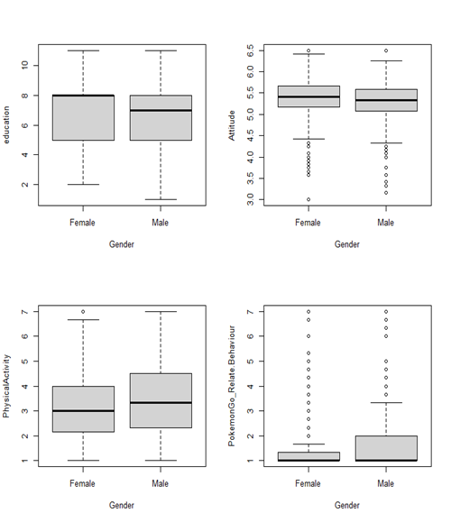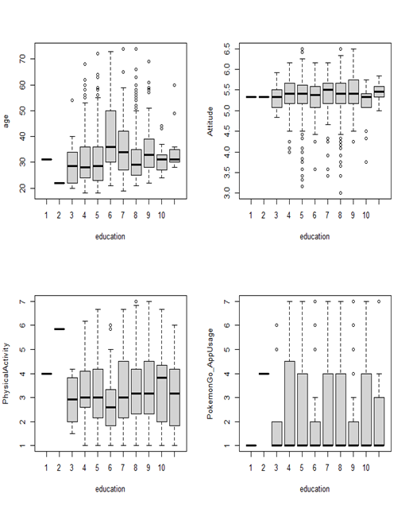

Plot 3.5: Boxplots of Education level vs 4 other variables

Plot 3.4: Boxplots of Gender vs 4 other variables

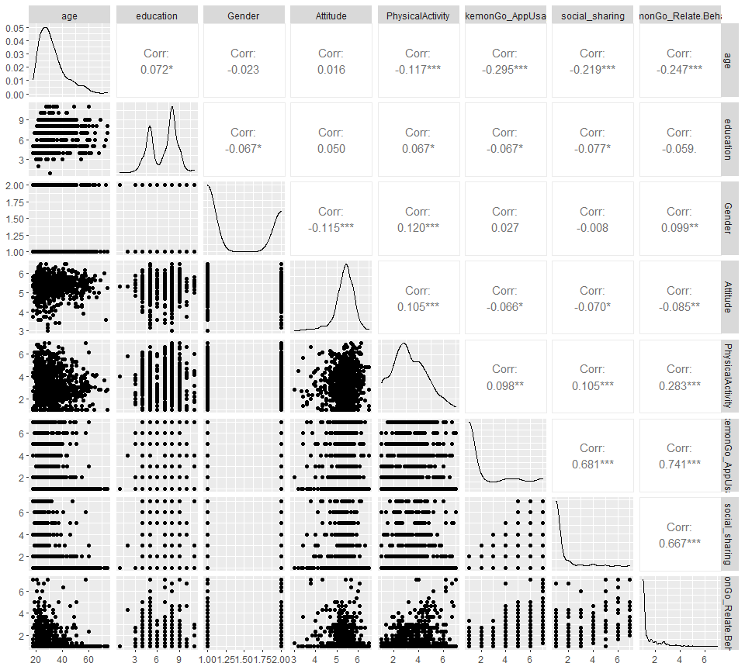

Plot 3.3: Scatter plot of data distribution

# 

# 4. Methodology

Polynomial linear regression model, a linear regression model with a degree of coefficient of more than one, is a model combining interactions between variables (Abhigyan, 2020). Polynomial regression can model the non-linear relationship between dependent and independent variables by adding polynomial terms to linear regression, such as the square of a variable (Agrawal. 2021). Polynomial regression was selected as the most suitable approximation of relations between variables can be provided. Some variables, in reality, have correlations with others or themselves. Simple linear regression, however, cannot model these interactions, leading to large error and inaccurate relationship estimation. With polynomial terms, we built up a better model for relations observations. A vast range of models, also, can be applied in the polynomial regression model, including linear, Gamma, and Poisson. The curvature of a polynomial regression model, moreover, is flexible (Pant. 2019). We can fit a wide range of positive values. Due to accuracy and flexibility, we select the polynomial regression model. A linear model was applied as it is easy for interpretation, as well as an explanation. There are four assumptions for the polynomial linear model. The behavior of a response variable, to begin with, can be explained by an additive relationship (both linear and curvilinear are plausible) between a response variable and several explanatory variables. It is essential that the relations between a response variable and all explanatory variables are linear or curvilinear. The independent variables, additionally, should be independent of each other. Last but not least, the errors must be independent and normally distributed, following a mean zero and constant variance (Abhigyan. 2020). We examine the following assumption after obtaining the best model by the stepwise selection method.

After developing a full linear model, stepwise selection, using AIC as criteria, was applied to select the best model. Stepwise regression is a step-by-step iterative and automatic model selection approach (Adam Hayes, 2021), based on backward regression and combining with forward. With this approach, we can re-examine the importance of variables, as well as correct the misleading caused by backward selection. For instance, it is plausible that a variable, removed in the backward selection, is included in the first stage of the forward selection method. Applying the stepwise selection method, we can include that variable again, for obtaining the best model (R. R. Hocking, 1967). McElreath (2016) revealed that Akaike Information Criteria (AIC) is a well-known information criterion, for evaluating the data-fitting performance of a model. The model with the smallest AIC is the best as describing the greatest amount of information with the smallest amount of variables (Bevans, 2021). It is necessary for checking the model assumption, to guarantee that model can be applied. The assumptions were examined by all four plots in **Plot 4.2**, the explanation and examination of assumption plots were written below.

According to the plot, Residuals vs Fitted in **Plot 4.2**, the pattern of residuals is not obvious, suggesting that the assumption of linear or curvilinear is acceptable. The residuals spread equally around the zero line, proved that the error terms have the same variance. Outliers, additionally do not exist as no residual standing away from the pattern (Department of Statistics Online Programs. 2018); Although having a light tail, Normal Q-Q plot suggested that the dependent variables, inside the model, are normally distributed (Ford. 2015). In the Scale-Location plot, Since the red line is approximately horizontal across the plot, with no clear pattern. In this way, the spreading of the residuals is random, as well as in the neighborhood of equal for all fitted values. (Zach. 2020). Observing Residuals Vs Leverage, the last plot in **Plot 4.2**, there is no points affecting the trend much. In this way, there are no outliers. Based on the graphs in **Plot 4.2**, the polynomial linear regression model, demonstrated in the summary, was applied for studying the relations between Pokémon Go and the amount of physical activity. The detailed final model was demonstrated in **Table 4.1**.

|  |  |  |  |  |
| --- | --- | --- | --- | --- |
| **Formula** | | | | |
| PhysicalActivity = age + education + Gender + Attitude + PokemonGo_AppUsage + PokemonGo_Relate.Behaviour + Attitude* Attitude + PokemonGo_Relate.Behaviour* PokemonGo_Relate.Behaviour + age*education + education*Attitude | | | | |
| Coefficients | Estimate | Std. Error | t value | Pr(>|t|) |
| (Intercept) | 6.136942 | 3.010388 | 2.039 | 0.04176 |
| age | 0.012821 | 0.015683 | 0.818 | 0.41382 |
| education | -0.279905 | 0.284092 | -0.985 | 0.32474 |
| Gender | 0.278323 | 0.084595 | 3.290 | 0.00104 |
| Attitude | -1.761775 | 1.013901 | -1.738 | 0.08260 |
| PokemonGo_AppUsage | -0.198716 | 0.035205 | -5.645 | 2.17e-08 |
| PokemonGo_Relate.Behaviour | 0.973577 | 0.207318 | 4.696 | 3.03e-06 |
| I(Attitude^2) | 0.155076 | 0.097228 | 1.595 | 0.11104 |
| I(PokemonGo_Relate.Behaviour^2) | -0.046845 | 0.029368 | -1.595 | 0.11101 |
| age*education | -0.003554 | 0.002289 | -1.553 | 0.12079 |
| education*Attitude | 0.085761 | 0.051815 | 1.655 | 0.09822 |

*Table 4.1: Formula and Summary of Final Model*

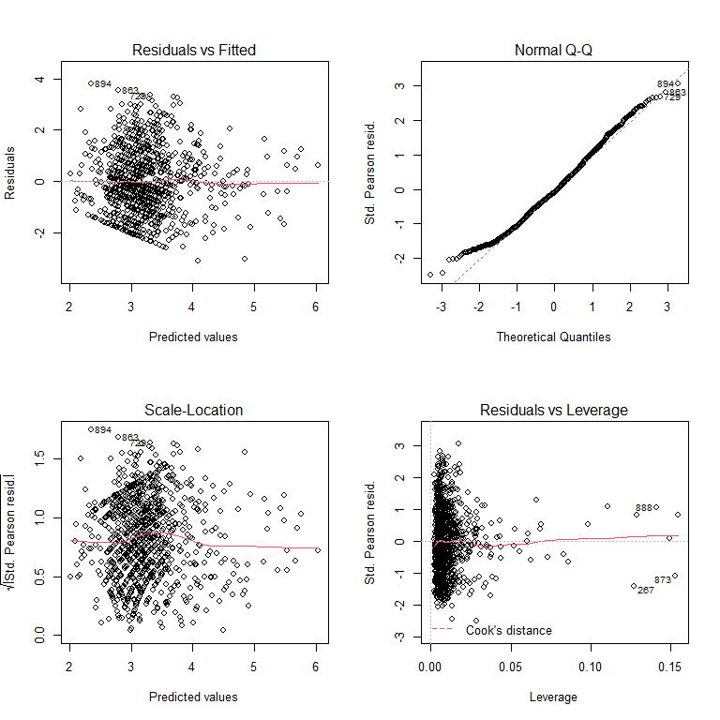

Plot 4.2: model assumption plots

# 5. Result Analysis

With the polynomial regression model constructed before, we answered the questions mentioned in the “research objectives” session. In accordance with the summary (**Table 4.1)**, the estimate of ***PokemonGo_AppUsage*** is -0.198716, with a variation of approximately 0.0002460, meaning that 1% increase of App usage lower -0.198716 amount of general physical activity. In contrast with the expectation, playing Pokémon Go frequently negatively affects the amount of physical activity. This phenomenon can be related to the variable ***PokemonGo_Relate.Behaviour***. Unlike ***PokemonGo_AppUsage***, **Table 4.1** showed that the estimates ***PokemonGo_Relate.Behaviour*** is 0.973577, possibly meaning activities related to Pokémon Go increase amount of Physical activities, instead of playing Pokémon Go. For explaining and examining this phenomenon, variable ***PokemonGo_Relate.Behaviour*** was removed from the model, and the result was showed in **Table 5.1.** According to **Table 5.1**,thevalues of ***PokemonGo_AppUsage*** became positive after the elimination of the variable ***PokemonGo_Relate.Behaviour***. Meaning that if other factors were fixed, the PokemonGo_Relate.Behaviour acted as a suppressor of the amount of physical activity. It, thus, is obvious that the positive effects of Pokémon Go app usage on physical activity restricted by Pokémon Go related activity rather than general physical activity like walking or cycling. Despites the variables mentioned before, there are more variables related to the amount of physical activity.

**Table 4.1** manifested that ***age*** and ***Gender*** increase the amount of physical activity, while ***education*** and ***Attitude*** negatively affects the frequency of it. In **Table 4.1**, there is correlation between ***age*** and education level (labelled as ***education***), forming a new variable, ***age*education***, representing the interaction variable. Education level and ***Gender***, in reality, is related to the attitude of participants towards physical activity***.*** In accordance with **plot 5.3**, the average attitude score of participants, with first three education level, are lower than the participants accepting higher education level. This represented that participant with higher education held a more active attitude towards physical activity. Moreover, the formation of new interaction variable, ***education*Attitude*** presented in Table 4.1, proved the correlation between education level and attitude towards physical activity. Besides education level, **Plot 5.3** represented that female have more positive attitude towards physical activity, comparing with male. (Note: in variable Gender, female was labelled as “1”, while male was represented by “2”.) In this way, both Gender and education have relationships with the amount of physical activity, proving that ***Attitude*** is a key factor. In contrast to the above situation, male have higher amount of physical activity (represented by the positive estimates in **Table 4.1**), being plausible that the attitude towards physical activity is not positive. In fact, **Table 4.1** showed that the estimated value of variable ***Attitude*** is negative (-1.761775). Although seems unreasonable, a positive attitude towards physical activity reduce the amount of physical activity.

|  |  |  |  |  |
| --- | --- | --- | --- | --- |
| **Formula** | | | | |
| PhysicalActivity = age + education + Gender + Attitude + PokemonGo_AppUsage + Attitude* Attitude + age*education + education*Attitude | | | | |
| Coefficients | Estimate | Std. Error | t value | Pr(>|t|) |
| (Intercept) | 7.070780 | 3.010388 | 3.164619 | 0.0257 |
| age | -0.001712 | 0.016454 | -0.104 | 0.9171 |
| education | -0.016170 | 0.298011 | -0.054 | 0.9567 |
| Gender | 0.392655 | 0.088170 | 4.453 | 9.43e-06 |
| Attitude | -2.156115 | 1.060194 | -2.034 | 0.0423 |
| PokemonGo_AppUsage | 0.051826 | 0.021254 | 2.438 | 0.0149 |
| I(Attitude^2) | 0.230975 | 0.101574 | 2.274 | 0.0232 |
| age*education | -0.001736 | 0.002289 | -1.553 | 0.12079 |
| education*Attitude | 0.085761 | 0.051815 | 1.655 | 0.09822 |

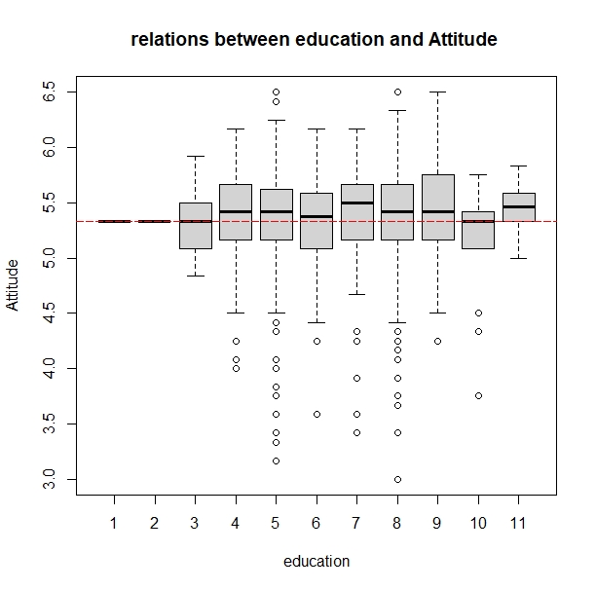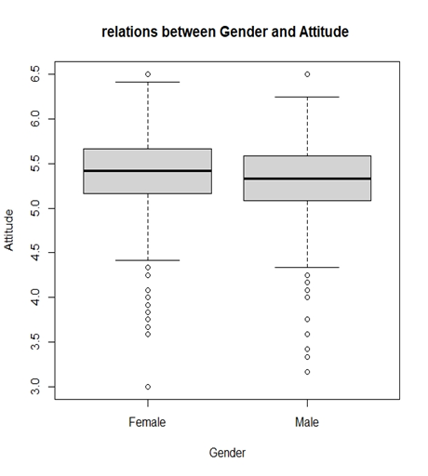

*Table 5.1: Formula and Summary of Model without “****PokemonGo_Relate.Behaviour***”

Plot 5.3: boxplot for relations between Gender and Attitude

Plot 5.2: boxplot for relations between education and Attitude

# Discussion

**Conclusion**

# Reference

# Agrawal Raghav. (2021). “All you need to know about Polynomial Regression”. Analytics Vidhya. https://www.analyticsvidhya.com/blog/2021/07/all-you-need-to-know-about-polynomial-regression/

# Bevans Rebecca. (2021). "An introduction to the Akaike information criterion". Scribbr. https://www.scribbr.com/statistics/akaike-information-criterion/

# Bradfield & Underhill. (2004). "IntroSTAT". 2nd. Department of Statistical Sciences, University of Cape Town. p.181-183 https://books.google.co.uk/books?id=f6TlVjrSAsgC&lpg=PP1&pg=PA181&redir_esc=y#v=onepage&q&f=false

# Buraimo Babatunde, Jones Helen & Millward Peter. (2011). "Adult participation in sport: Analysis of the Taking Part Survey". department for culture, media, and sport. https://assets.publishing.service.gov.uk/government/uploads/system/uploads/attachment_data/file/137986/tp-adult-participation-sport-analysis.pdf

# Cortina Jose. (1992). "What Is Coefficient Alpha? An Examination of Theory and Applications". American Psychological Association, Inc. p.101

# Cronbach, Lee J. (1951). "Coefficient alpha and the internal structure of tests". Psychometrika. Springer Science and Business Media LLC. 16 (3): 297-334

# Department of Statistics Online Programs. (2018). “4.2 - Residuals vs. Fits Plot”. The Pennsylvania State University. https://online.stat.psu.edu/stat462/node/117/

# Eysenbach Gunther. (2016). "Influence of PokÃ©mon Go on Physical Activity: Study and Implications". Journal of Medical Internet Research. https://www.ncbi.nlm.nih.gov/pmc/articles/PMC5174727/

# Fisher Tim. (2021). "What Is Augmented Reality?". Lifewire. https://www.lifewire.com/augmented-reality-ar-definition-4155104

# Ford Clay. (2015). “Understanding Q-Q Plots”. The University of Virginia. https://data.library.virginia.edu/understanding-q-q-plots/

# Ganti Akhilesh. (2021). "Median". Investopedia. https://www.investopedia.com/terms/m/median.asp

# Glen Stephanie. (2021). "Cronbachâs Alpha: Simple Definition, Use and Interpretation". Statistics How To. https://www.statisticshowto.com/probability-and-statistics/statistics-definitions/cronbachs-alpha-spss/

# Goforth Chelsea. (2015). "Using and Interpreting Cronbachâs Alpha". The University of Virginia Library. https://data.library.virginia.edu/using-and-interpreting-cronbachs-alpha/

# Hayes Adam. (2021). "Stepwise Regression". Investopedia. https://www.investopedia.com/terms/s/stepwise-regression.asp

# Hocking, R. R. (1976). A Biometrics Invited Paper. The Analysis and Selection of Variables in Linear Regression. Biometrics, 32(1), 1â49. https://doi.org/10.2307/2529336

# Jacquet Jennifer. (2011). "The pros & cons of Amazon Mechanical Turk for scientific surveys". Scientific American. https://blogs.scientificamerican.com/guilty-planet/httpblogsscientificamericancomguilty-planet20110707the-pros-cons-of-amazon-mechanical-turk-for-scientific-surveys/

# Kostoulas Achilleas. (2013). "On Likert scales, ordinal data and mean values". Achilleas Kostoulas. https://achilleaskostoulas.com/2013/02/13/on-likert-scales-ordinal-data-and-mean-values/

# McElreath Richard. (2016). "Statistical Rethinking: A Bayesian Course with Examples in R and Stan". CRC Press. p.189

# McNeish, D., Wolf, M.G. (2020). Thinking twice about sum scores. Behav Res 52, p.2287â2305. https://doi.org/10.3758/s13428-020-01398-0

# Pardoe Iain. (2017).

# Reilly Luke. (2017). "PokÃ©mon GO Coming to Smartphones". IGN Entertainment. https://www.ign.com/articles/2015/09/10/pokemon-go-coming-to-smartphones

# Seippel Ornulf. (2006). "The Meanings of Sport: Fun, Health, Beauty or Community?". Tandfonline https://www.tandfonline.com/doi/full/10.1080/17430430500355790?scroll=top&needAccess=true

# Sengupta Somak. (2020). "Gamma Distribution Explained | What is Gamma Distribution?". Great Learning. https://www.mygreatlearning.com/blog/gamma-distribution/

# Smith, C. (2017, November 12).80 amazing Pokemon Go statistics. RetrievedNovember 17, 2017, from https://expandedramblings.com/index.php/pokemon-go-statistics/.

# Stacy, E. W. (1962). A Generalization of the Gamma Distribution. The Annals of Mathematical Statistics, 33(3), 1187â1192. http://www.jstor.org/stable/2237889

* Webster Andrew. (2015). "With PokÃ©mon Go, Nintendo is showing that it takes mobile seriously". The Verge. https://www.theverge.com/2015/9/10/9300101/pokemon-go-nintendo-mobile-games
* Zach. (2020). “How to Interpret a Scale-Location Plot (With Examples)”. Scatology. https://www.statology.org/scale-location-plot/